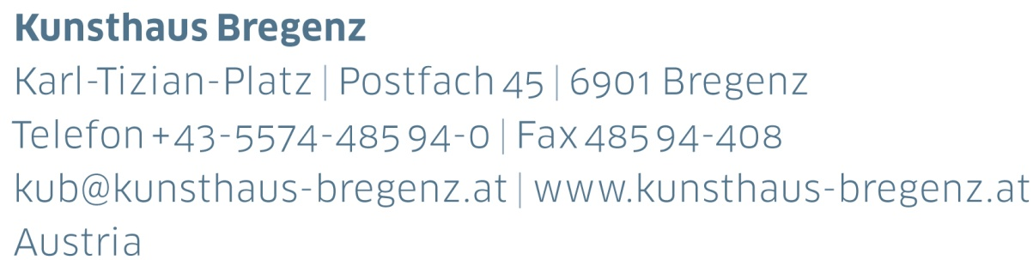

KUB 2024.03 | Press Release

Tarek Atoui  
12 | 10 | 2024 — 12 | 01 | 2025

Press Conference

Thursday, October 10, 2024, at 11 am

Opening

Friday, October 11, 2024, at 7 pm

Performance Weekend

Thursday, October 24–Saturday, October 26, 2024

Starting every evening at 6 pm

Press photos available for download at

[www.kunsthaus-bregenz.at/en/press/tarek-atoui](http://www.kunsthaus-bregenz.at/en/press/tarek-atoui)

Tarek Atoui is a musician and an artist. He has already performed twice in Bregenz and with great success: at KUB’s twentieth anniversary celebration in 2017 and as part of the Talks on Music and the Arts project series in 2018. For his performances, he collaborates with musicians and amateurs, and these collaborations—public interventions or workshops with sound pieces—are explorations of sound phenomena.

Atoui investigates music history, acoustic vibrations, and the interplay of body and sound. He is particularly interested in the development of new instrumentation and constructs novel sound objects, instruments, and listening aids. In the process, he creates original solutions that evolve; they learn from the space in which their sound originates and from the hands operating them. On his travels, Atoui explores regional cultural traditions, which he incorporates into his works, for instance, combining sounds from different port cities with characteristic objects from the places.

For the Serralves Museum in Porto in 2022, Atouihe combined sounds from the city’s port with wooden containers for compost, enhanced with marble figures made and sold at the port of his hometown Beirut, where a destructive explosion occurred on August 4, 2020. The project is part of his Waters’ Witness series, an immersive soundscape that connects the identities of port cities from Athens to Abu Dhabi and was exhibited in ever-changing versions at—in addition to the Serralves Museum—the Fridericianum in Kassel in 2020, Mudam and Park Dräi Eechelen in Luxembourg in 2022–23, and MCA Sydney in 2023.

Along with on-site research, Atoui’s works include historical investigations. The artist takes the sounds of ethnic instruments from the Musical Instruments Museum in Berlin as a starting point to develop novel instruments. He also works with electroacoustic experiments and computer systems that connect with listeners and musicians to synthesize previously unknown sounds. This involves playful experimentation and a musical experience that conveys spontaneity and a sense of the now. Characteristic for him are situations that are open to the unexpected and that incorporate performative elements as an irritation. Atoui thinks of music as changeable, as something that is inspiring and is inspired. He explains: “It’s about giving things the opportunity to change and adapt to their time and place.” Kunsthaus Bregenz, with its acoustically sensitive spaces, is an ideal sounding board for Atoui’s work.

From Thursday, October 24, to Saturday, October 26, 2024, KUB is presenting a performance weekend with Tarek Atoui and the international musicians Laure Boer, Gobi Drab, Susanna Gartmayer, Mazen Kerbaj, DJ Sniff, and Ziúr. Collaboration and encounters are at the heart of the series. The performances start at 6 pm on each of the three evenings. Each evening is dedicated to a concept that activates the floors of KUB in a different way and offers visitors a unique sound experience. Further details to follow soon.

Biography

Tarek Atoui

Tarek Atoui(b. 1980, Beirut) lives and works in Paris as a musician and sound artist. He studied contemporary and electronic music at the Conservatoire à Rayonnement Régional in Reims and was an artist-in-residence at the New Museum in New York. The musician participated in documenta 13 with a work that was inspired by Erkki Kurenniemi’s DIMI synthesizers. As an artist, Atoui has exhibited at institutions such as the Mudam Luxembourg, the Fondation Serralves in Porto, The Contemporary Austin, and the FLAG Art Foundation in New York, all in 2022, as well as at the Fridericianum in Kassel and the Sharjah Art Foundation in Sharjah in 2020, and at the NTU Centre for Contemporary Art Singapore in 2018. His works are part of several collections, notably the Tate Modern Collection in London, the Solomon R. Guggenheim Collection in New York, the Nouveau Musée de Monaco Collection, the Pinault Collection, the Kadist Collection, the French national collection, and the collection of the Sharjah Art Foundation.

Partners and Sponsors

Kunsthaus Bregenz is grateful to its partners for their generous financial support and their ongoing commitment to culture.

