KUB 2018.04 | Press Release
Tacita Dean
20 | 10 | 2018 –
06 | 01 | 2019

Press Conference
Thursday, October 18, 2018, 11 am

Opening Reception
Friday, October 19, 2018, 7 pm

Press photos for download
www.kunsthaus-bregenz.at

“Any artist who works in paint or chalk or film, or whatever, knows that sometimes the medium itself will give you something entirely unexpected, and something far better than what you intended.”

Tacita Dean, The Observer, March 11, 2018

Tacita Dean is one of the most important artists working today. She has exhibited at Kunsthaus Bregenz once before in 2003/2004 in the group exhibition Remind... with Eija-Liisa Ahtila, Anri Sala, and Jane and Louise

Her subject matter is often historical, touching on memory and empathy, the forces of nature and the traces left behind by humanity. Her works, from her early chalk on blackboard drawings to her four or more leaf clover collection, round stones, and found postcard interventions become ardent witnesses to a lost past, and the desire to capture, in imagery, the incomprehensible. Dean’s works in film also demonstrate her insistence on a medium’s materiality reinforcing her stance against a work’s arbitrary and careless exhibition. When the last laboratory printing 16mm film was suddenly closed in London in 2011, she began her campaign to preserve the medium of photochemical film by writing an article published in The Guardian newspaper. (www.savefilm.org).

On the ground floor of Kunsthaus Bregenz visitors encounter two monumental chalk drawings. Using white chalk on a blackboard surface, Dean has drawn a mountain landscape as sublime and impressive as the story that gave the work its title. In the 17th century, an avalanche fell in the mountain valley of Montafon, south of Vorarlberg. Legend has it that a priest, while blessing the dead was himself then buried by a second avalanche only to be miraculously uncovered by a third. Dean has just completed a second, similarly monumental drawing especially for Kunsthaus Bregenz called Chalk Fall, 2018, which depicts the collapse of a chalk cliff, deliberately matching her subject matter with the medium she has used to make it, while at the same time mirroring the fall of white on white in The Montafon Letter. Whilst the sky and mountain ridges, forces and fissures, and the vast expanses and subsuming gloom of these works might recall the tradition of great English landscape painters like Constable and Turner, Dean’s works are also very human in that the images are covered with Dean’s handwritten notes that maybe read as both scars on nature, as well as instructions for viewing.

The extensive exhibition at Kunsthaus Bregenz will include three of her most significant film works, screened across three floors.

Antigone, 2018, is Tacita Dean’s most recent and most elaborate film project, which premiered in the spring of 2018 in the new Burlington Garden spaces at the Royal Academy of Arts in London, the third in an unprecedented collaboration of simultaneous exhibitions across three venerable London institutions that also included The National Gallery and the National Portrait Gallery. Antigone is an hour-long dual synchronised 35 mm film projection. Based on the mythical figure Antigone, which is also the name of the artist’s sister, the film addresses time, transience and the mythological, as well as the materiality of film itself. Antigone, daughter of Oedipus, led her blind and lame father out of Thebes through the wilderness to Colonus. Celebrating natural phenomena such as light and the sky, Tacita Dean transports viewers from Bodmin Moor in England to Yellowstone Park and the rangelands of Wyoming where she filmed a rare solar eclipse. On August 21, 2017, the moon’s shadow swept across the US from its west to east coast. Using her own aperture gate masking system that mimics the movement of the moon by partially obscuring each frame, Dean exposed the same frame of negative multiple times, combining different places and times within a single picture, similar to how images from one’s own memories and experiences can merge together with mythologies and present events to become one.

Six screens glimmer within the darkened space of the second floor. They all display Merce Cunningham. The dancer, a master of movement, sits motionless in a mirrored dance studio, his fingertips touching in a posture reminiscent of the earliest days of photography when long exposure times were necessary. Cunningham performs 4’33”, his partner John Cage’s most famous work, a piece of music without sound that celebrates silence. In Merce Cunningham performs STILLNESS…, 2008, Cunningham shifts his pose for each movement of the three-part piece. Tacita Dean’s homage is part of a series of film portraits of artists, including David Hockney, Julie Mehretu, Claes Oldenburg and Cy Twombly. It is the advanced age of the dancer’s body that we are aware of: his thoughtful concentration and serene calm. Merce Cunningham died aged 90 in 2009.

FILM, 2011, on the third floor, as its self-referential title suggests is a portrait of the medium of film. Made for Tate Modern’s Turbine Hall in 2011, as part of the Unilever Series of commissions, at a time when photochemical film was in danger of disappearing, the work is a celebration of the materiality and the specific atmospheric qualities of film. Dean constructed this silent portrait-format film using various early film techniques that included masking in the gate, glass matte painting, backdrops and hand-colouring. Also referencing the east wall of the Turbine Hall itself, the images are like frames of film with sprockets and are intensely illuminated, their colours glowing like the strata of rock. The film has the quality of the iris of an eye, dilating with light to become a brilliant animated surface.

Biography
Tacita Dean

Tacita Dean was born in 1965 in Canterbury, UK. She currently lives and works in Berlin and Los Angeles.

Dean has been awarded numerous prizes including the Hugo Boss Prize (2006), the Sixth Benesse Prize at the 51st Venice Biennale (2005), and the Kurt Schwitters Prize for Visual Art (2009). Dean has had solo exhibitions in internationally established museums such as Tate Britain, London (2001), Museu d’Art Contemporani de Barcelona (2001), Schaulager, Münchenstein/Basel (2006), Solomon R. Guggenheim Museum, New York (2007), Fondazione Nicola Trussardi, Milan (2009), MUMOK, Vienna (2011), Instituto Moreira Salles, Rio de Janeiro (2013), Fundación Botín, Santander (2013), Australian Centre for Contemporary Art, Melbourne (2013), Statens Museum for Kunst, Copenhagen (2014), Museo Tamayo, Mexico City (2016), National Portrait Gallery, The National Gallery & Royal Academy of Arts, London (2018).

Her works were also included in dOCUMENTA (13) (2012), 55th Venice Biennale (2013), as well as the 19th Biennale of Sydney (2014).

KUB Publication
Tacita Dean

In her films, photographs and sound works, Tacita Dean uses silence, time and entropy to describe particular human sensibilities. The artist’s most recent works at Kunsthaus Bregenz are monumental chalk drawings on blackboards that generate timeless imagery rooted in art history using the very simplest of materials. KUB will be publishing an artist’s book with Tacita Dean.

Edited by Kunsthaus Bregenz, Thomas D. Trummer
Graphic Design: Martyn Ridgewell
German / English
Date of publication: December 2018

KUB Online-Shop
www.kunsthaus-bregenz.at

KUB Artist’s Edition
Tacita Dean
Antigone (Bregenz edition)

Exclusive special editions for Kunsthaus Bregenz are produced in close collaboration with the artist and their chosen materials.

Tacita Dean’s limited edition for Kunsthaus Bregenz consists of a colour photograph made from two separate negatives, which show a doubling of the mythical moment of the moon passing across the sun during an eclipse just before and after totality. The single piece of photographic paper has been exposed with two negatives mirroring the distinctive process, which Tacita Dean adopts in FILM and Antigone, where different images are exposed through masking on different parts of the photochemical film frame.

Tacita Dean
Antigone (Bregenz edition), 2018
Hand printed colour photograph from two negatives on Fuji Pearl paper, 24.5 x 57.5 cm
Limited edition of 25 copies + 5 A.P., signed and numbered
€ 4,000 incl. 10 % VAT, plus postage, packaging, and custom duties

KUB Online-Shop
shop.kunsthaus-bregenz.at

Upcoming
KUB Billboards

Maeve Brennan
08 | 11 | 2018 —
20 | 01 | 2019
Seestraße, Bregenz

Opening and artist talk
Thursday, November 8, 2018, 7 p.m.
Kunsthaus Bregenz

KUB Billboards
Maeve Brennan

Maeve Brennan´s (*1990 in London) work explores the political and historical resonance of material and place. She is a co-founder of the film collective Sharna Pax, who work between the fields of visual art, anthropology and documentary. Solo exhibitions include The Drift at Chisenhale Gallery, London; Spike Island, Bristol, and The Whitworth, University of Manchester (all 2017), and Jerusalem Pink, OUTPOST, Norwich (2016). She was educated at Goldsmiths, University of London, was a fellow of the Home Workspace Program at Ashkal Alwan, Beirut (2013 — 14), and is the recipient of the Jerwood/ FVU Award 2018.

The billboards along Bregenz’s Seestrasse, the town’s busiest throughfare, are a fixture of Kunsthaus Bregenz’s program. In 2018, KUB Billboards will feature works by four young female artists. Maeve Brennan concludes the year, following Flaka Haliti (Kosovo), Alicia Frankovich (New Zealand) and Lili Reynaud Dewar (France)

Partners and Sponsors
Kunsthaus Bregenz would like to thank its partners
for their generous financial support and commitment to culture.

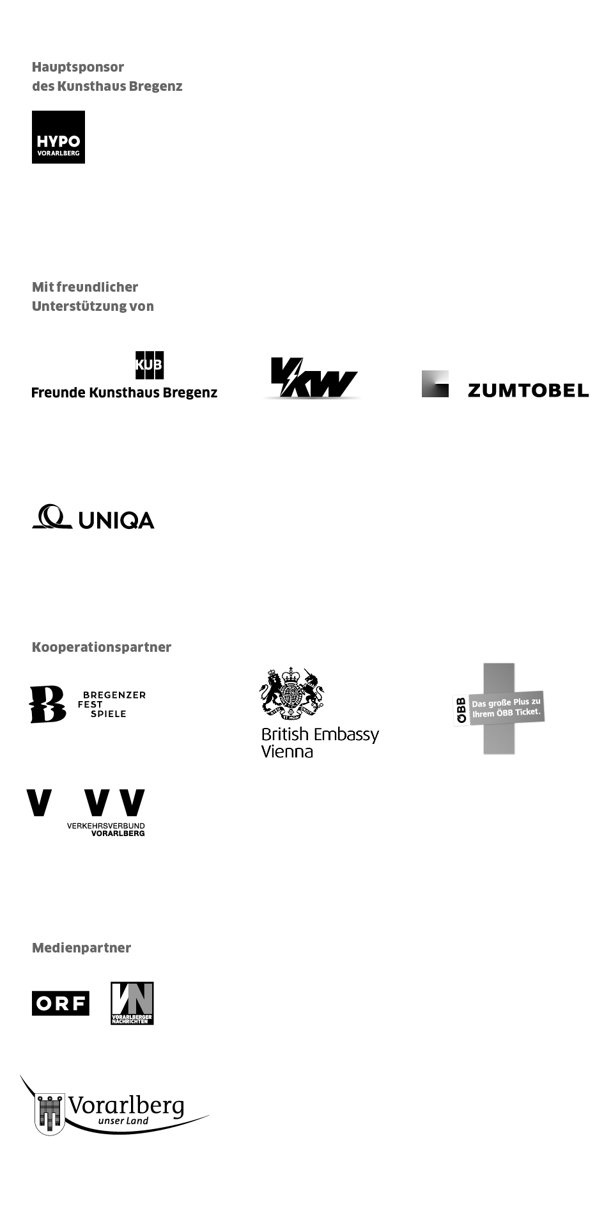

Director
Thomas D. Trummer

Chief Executive
Werner Döring

Curator
Rudolf Sagmeister

Exhibition Management
Stefan Wagner | ext. -413
s.wagner@kunsthaus-bregenz.at

Communication
Martina Feurstein | ext. -410
m.feurstein@kunsthaus-bregenz.at

Development | Sponsoring
Lisa Hann | ext. -437
l.hann@kunsthaus-bregenz.at

Art Education
Mareile Halbritter ext. -417
m.halbritter@kunsthaus-bregenz.at

Events | Visitor Service
Barbara Straub ext. -415
b.straub@kunsthaus-bregenz.at

Publications
Katrin Wiethege | ext. -411
k.wiethege@kunsthaus-bregenz.at

Artist’s Editions
Rudolf Sagmeister, Katrin Wiethege

Edition Sales
Caroline Schneider-Dürr | ext. -444
c.schneider@kunsthaus-bregenz.at

Opening Hours
Tuesday to Sunday 10 am – 6 pm
Thursday 10 am – 8 pm
Ticket Counter | ext. -433

