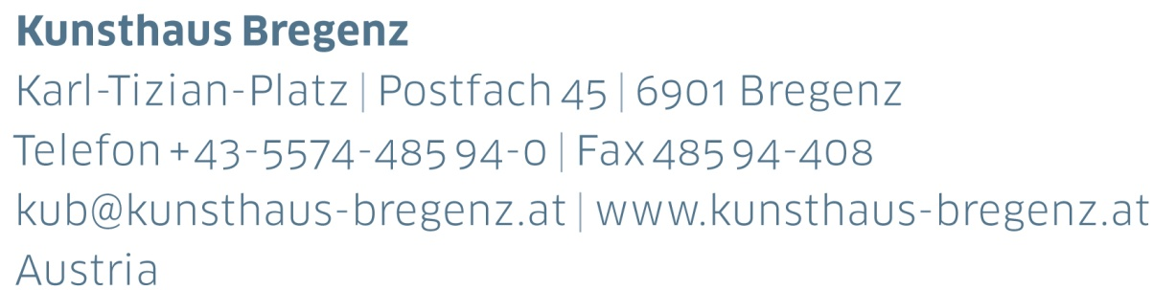

KUB 2017.03 | Press Release
Peter Zumthor
Dear to Me
16 | 09 | 2017 –
07 | 01 | 2018

Press Conference
Thursday, September 14, 2017, 11 am

Opening Reception
Friday, September 15, 2017, 7 pm

Press photos for download
www.kunsthaus-bregenz.at

Life is too short. There are so many things I have already experienced and done in my life, but the number of things I still want to experience, to do and understand, is infinitely greater. And there are so many things I cherish, but I am convinced that there are as many and more that I would cherish if only I knew about them.

The invitation to mount an exhibition at Kunsthaus Bregenz has given me the opportunity to make a few of those dreams come true and to share them with all the visitors at the Kunsthaus.

Dear to Me: this is the title of the celebration that I am putting together with my family and my friends, with the literary scholar Brigitte Labs-Ehler, the musician Peter Conradin Zumthor and the fabulous team at the Kunsthaus. You are all invited to join us at this festival of the arts from September 2017 to January 2018.

Concerts, readings and conversations – top-notch, ambitious, surprising, playful, quirky, folkloric, magical, wild and exuberant – some 60 special events in all are planned, usually beginning on Thursday evenings and lasting until Sunday. Occasionally, on Sunday mornings, I will be talking with selected artists about their work. For these talks I am inviting composers, musicians, writers, philosophers, scientists, craftspeople and artisans.

A stage, a bar and ample seating will create an attractive and welcoming atmosphere in the foyer of Kunsthaus Bregenz. There, a biographical collage of my work, compiled by filmmaker Christoph Schaub, will also be screened. Different atmospheres will frame the events on the storeys above, containing a personal library of some 40,000 books; a garden created by artists Gerda Steiner and Jörg Lenzlinger on the top floor; and an almost empty room except for Hélène Binet’s black-and-white photographs of the paths that Dimitri Pikionis designed for the Acropolis. A punchcard and music box installed in the middle of the room will play the music that Olga Neuwirth composed especially for the exhibition.

I look forward to the coming months with great pleasure. Peter Zumthor

Biography
Peter Zumthor

Peter Zumthor works with his Atelier of around 30 people in the alpine setting of Haldenstein, Switzerland, producing architectural originals like Kunsthaus Bregenz, Therme Vals, Museum Kolumba Köln or the Steilneset Memorial in Vardø.

Partners and Sponsors
Kunsthaus Bregenz would like to thank its partners
for their generous financial support and the cultural commitment that accompanies it.

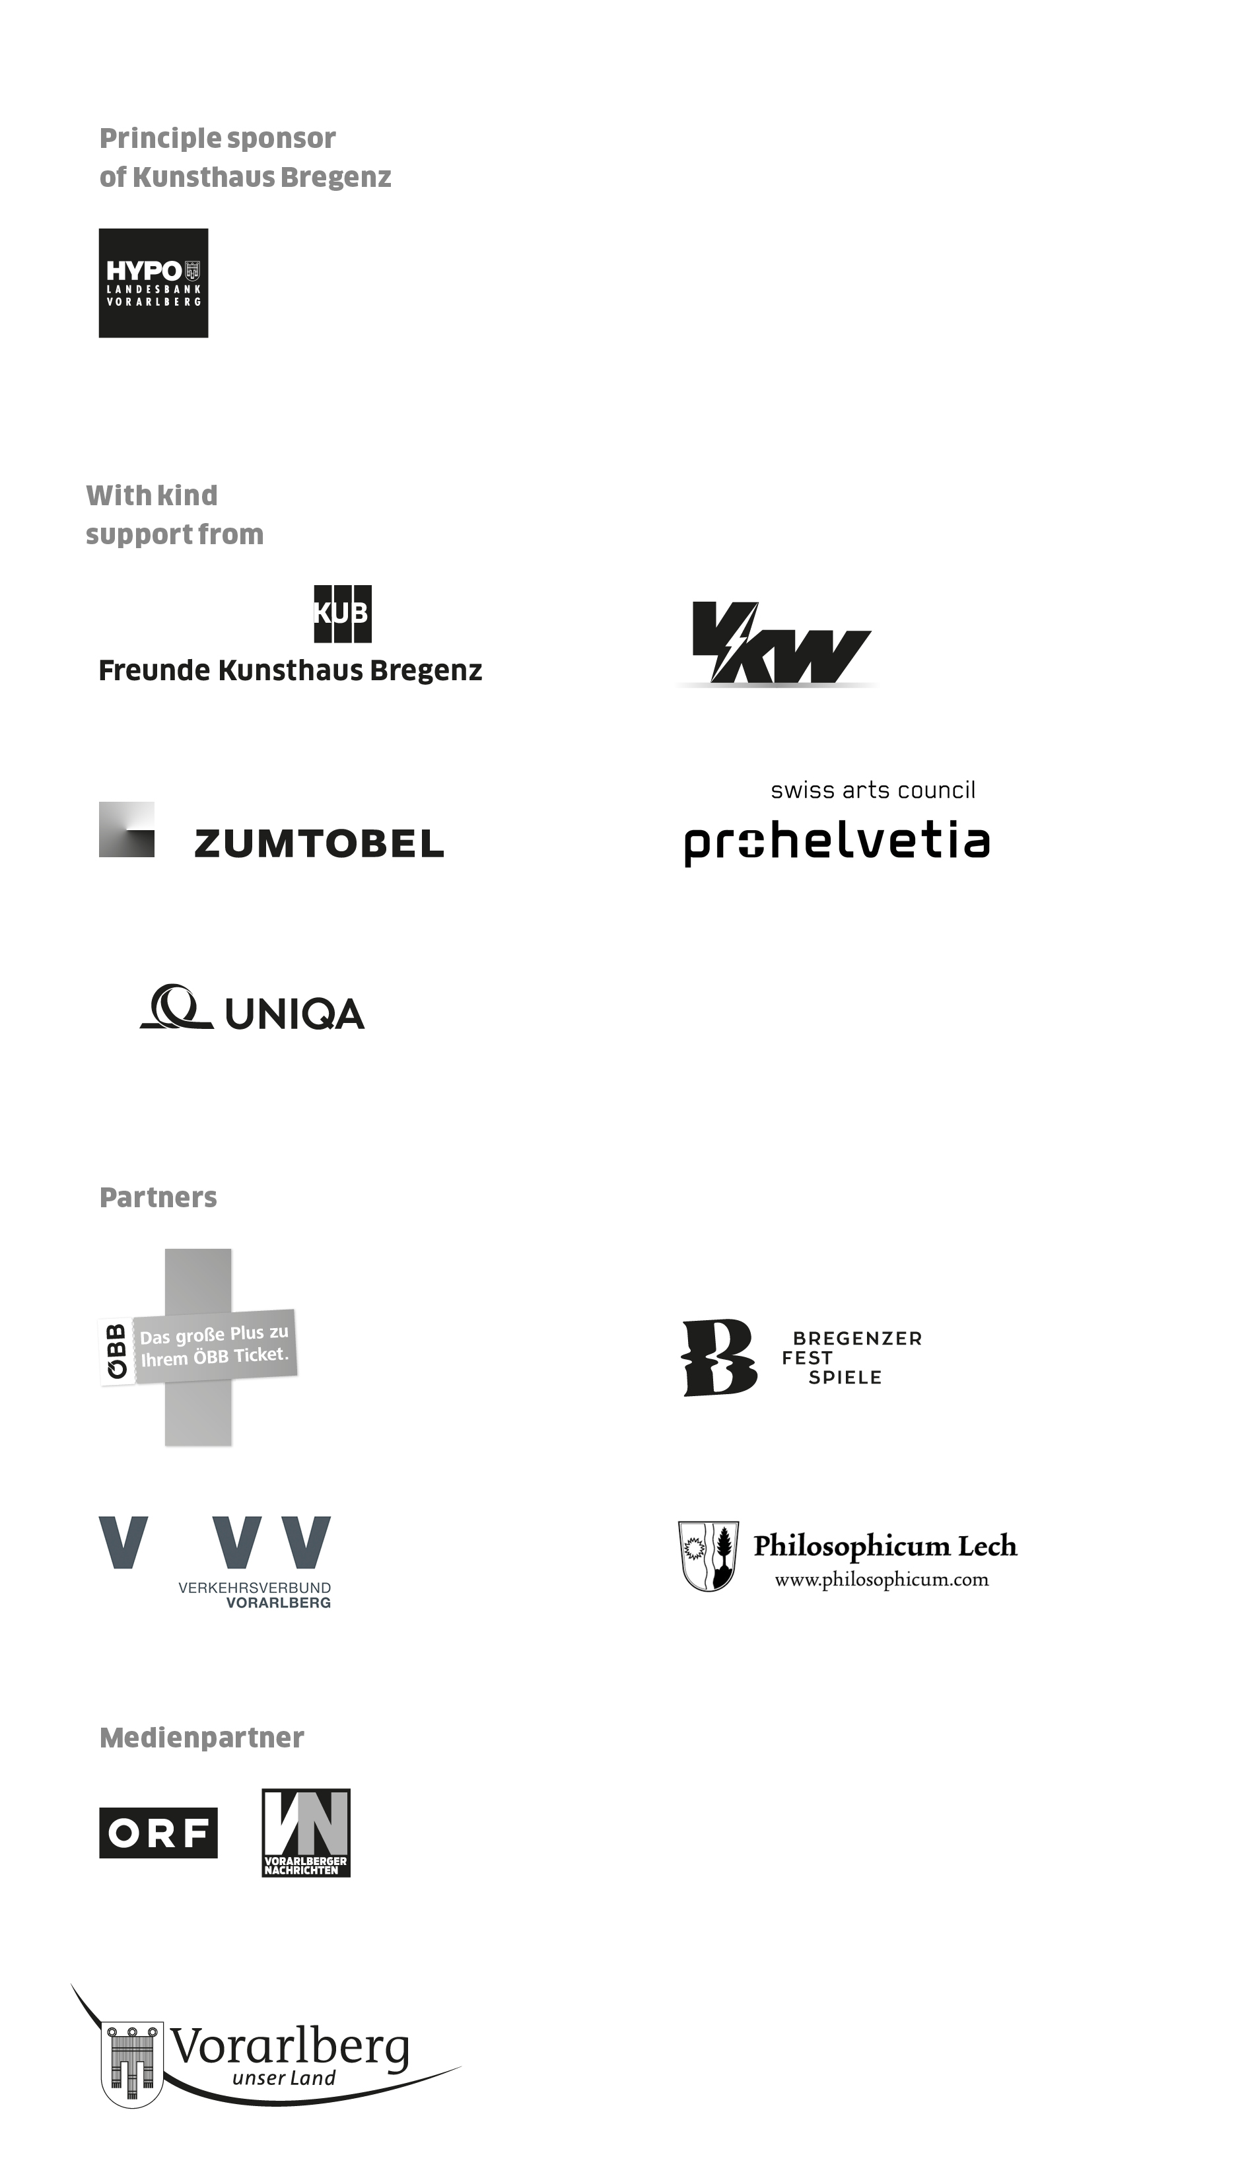

Director
Thomas D. Trummer

Chief Executive
Werner Döring

Curator
Rudolf Sagmeister

Marketing | Cooperation
Birgit Albers | ext. -413
b.albers@kunsthaus-bregenz.at

Development | Sponsoring
Lisa Hann | ext. -437
l.hann@kunsthaus-bregenz.at

Press | Online Media
Martina Feurstein | ext. -410
m.feurstein@kunsthaus-bregenz.at

Art Education
Barbara Straub ext. -415
b.straub@kunsthaus-bregenz.at
Mareile Halbritter ext. -417
m.halbritter@kunsthaus-bregenz.at

Publications | Artist’s Editions
Katrin Wiethege | ext. -411
k.wiethege@kunsthaus-bregenz.at

Edition Sales
Caroline Schneider-Dürr | ext. -444
c.schneider@kunsthaus-bregenz.at

Opening Hours
Tuesday to Sunday 10 am – 6 pm
Thursday 10 am – 8 pm
Ticket Counter | ext. -433

Summer Opening Hours 2017
July 1 to August 27 | daily 10 am – 8 pm
Ticket Counter | ext. -433
Assumption Day, August 15 | 10 am – 8 pm

