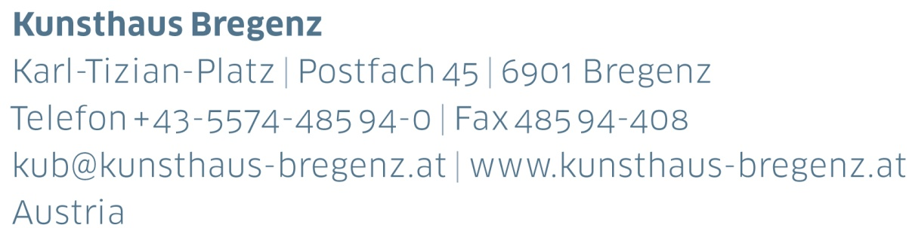

KUB 2019.02 | Press Release

Miriam Cahn  
DAS GENAUE HINSCHAUEN

13 | 04 – 30 | 06 | 2019

Preview! Talk with Miriam Cahn

Saturday, April 6, at 2 pm

Tour for the press with the artist

Thursday, April 11, 2019, 11 pm

Opening Reception

Friday, April 12, 2019, 7 pm

Press photos for download

www.kunsthaus-bregenz.at

“What does that actually mean today, this being a woman?”

Miriam Cahn

To coincide with her seventieth birthday in the summer of 2019, Miriam Cahn is presenting her first major institutional solo exhibition in Austria at Kunsthaus Bregenz.

The figures glow in fluorescent light, immersed in matt ultramarine. Their hair flows upwards, together with apparently weightless arms and hands. The figure to the left grabs towards a pale piece of fabric, displaying a veiled face evoking the Turin Shroud. The eyes of those portrayed are glazed and ghostly, the dark, shadowy mood one of shock. MARE NOSTRUM, the title of the painting, is the Latin term for the Mediterranean, but also the name for the Italian naval operation during 2013/2014 to rescue thousands of refugees at sea off Lampedusa. The painting is an unsparing document of the present crisis. It depicts drowned refugees sinking namelessly to the seabed.

On the third floor of Kunsthaus Bregenz, a selection of Miriam Cahn’s impressive paintings confronts current political and social debates. Not only the fate of the victims in the Mediterranean, but also violence – sexual, political, and religious violence – are subjects central to the work. Cahn is not averse to throwing real punches, such as in o. t., 2017, where a left hand catches the victim straight in the face. The culprit is a man with a flushed face, whose right hand grasps his erect phallus. The woman who has been struck is pale, her eyes blank. Her face and even the pale blue horizon are barely perceptible. The dramatic motif of provocative violence repeatedly returns in variations. In addition, there are depictions of the family, portraits as if painted by the Expressionists, and repeatedly the nude: children, women, men. They are portrayed in all their vulnerability: as perpetrators and victims, in desire and in isolation, deranged by dreams, loving, harsh, embracing, calling for help, masturbating, or dead.

The second floor features Miriam Cahn’s large-scale drawings from 1982. The works are dusty. At the time Cahn drew kneeling on the floor, working very rapidly and performatively. They display monumental forms associated with masculinity, such as doppelkanone, a series of ships, an oil platform, and the World Trade Center towers in steep perspective. What is striking here is the geometry and the doubling of some forms, the dynamics and spikiness, and above all the stage-like composition as well as the consistent use of a deep black evoking gloomy visions.

The first floor comprises works drawn in black chalk on white paper that resemble photographs. Most of these drawings, which Cahn assembles in series, date from the 1980s and early 1990s. In many, their painterly work and movement are visible.

On the ground floor there are drawings and color photographs. liebenmüssen – DAS GENAUE HINSCHAUEN, 2018, is a series of scans hanged densely together. These are black and white reproductions of her own paintings, mostly depicting the female gender. The woman as subject of the gaze, the exposure of the female body, and pornographic voyeuristic curiosity repeatedly appear in this series. Cahn is a feminist, who has titled a collection of her own texts DAS ZORNIGE SCHREIBEN. Cahn responds to the current #MeToo debate, to the portrayals of the female gender circulating in the media, but also to art history. As early as 1866, Gustave Courbet painted exposed female genitalia in The Origin of the World (Musée d’Orsay, Paris). “This is a central image for a lot of women making art because it shows that mix, between horny pornography and beauty,” explains Miriam Cahn.

Miriam Cahn is not shy of the subject of sexuality. She bases her art on the profane, entering into a dialogue of opposing equivalents with the seemingly sacral architecture of Kunsthaus Bregenz. Although both architect Peter Zumthor and the artist were born near Basel, they have never met in person – to accompany the Bregenz exhibition, a public conversation will be taking place between them for the first time.

Accompanying Events

Preview! Talk with Miriam Cahn

Saturday, April 6, at 2 pm

A Conversation between Miriam Cahn and Peter Zumthor Sunday, May 26, at 11 am

Biography

Miriam Cahn

Miriam Cahn, born in 1949 in Basel, Switzerland, was as early as 1982 to participate in documenta 7, Kassel. Her work has been presented internationally in numerous solo and group exhibitions, including Kunsthalle Basel (1983), Museum of Modern Art, New York (1984), Kunsthaus Zürich (1993), Fundación La Caixa, Madrid (2003), Neue Nationalgalerie, Berlin (2004), Le Plateau, Paris (2012), Museum Tinguely, Basel (2017). She was represented at documenta 14, Kassel (2017), and the 21st Biennale of Sydney (2018).

To coincide with her seventieth birthday in the summer of 2019, Miriam Cahn is presenting several exhibitions including Kunstmuseum Bern, Reina Sofía, Madrid, Haus der Kunst, Munich and Museum of Modern Art, Warsaw. Her exhibition at Kunsthaus Bregenz is her first major institutional solo exhibition in Austria.

She lives and works in Stampa in the canton of Graubünden, Switzerland.

KUB Publication

Miriam Cahn

Violence and love, escape and security, the gender struggle and loneliness, animal and human – in intense colors and expansive chalk lines, Miriam Cahn lends her subject matter eloquently sensual expression. Her committed and radical approach as an artist to such issues permeate the formal idiom of all the groups of works.

In the catalogue, various contributions shed light on the artistic import of her works as well as their significance in contemporary painting. Large-format photographs document the exhibition in Bregenz hung by Cahn herself, and present a great contemporary artist. This is the first comprehensive bilingual catalogue about Miriam Cahn’s work to be published for some years.

Edited by Thomas D. Trummer, Kunsthaus Bregenz

Essays by Burcu Dogramaci, Nina Schedlmayer   
and Thomas D. Trummer

Graphic design: Dagmar Reiche

German | English

Softcover, approx. 20.5 x 27.5 cm, approx. 160 pages

Date of publication: June 2019

Price: € 42,–

KUB Online-Shop

www.kunsthaus-bregenz.at

KUB Billboards

Miriam Cahn

The billboards located on Seestraße, the main thoroughfare in Bregenz, are an integral part of Kunsthaus Bregenz’s program. In 2019 they will return to their original form, extending each exhibition in Kunsthaus Bregenz into public space.

Miriam Cahn’s images painted in intense colors reference currently urgent issues: loneliness, violence not only between people but also the genders, sexuality, war and the seeking of refuge. At the same time, depictions of animals and landscapes evoke hopes of an existence in peace and harmony with the world.

Partners and Sponsors

Kunsthaus Bregenz would like to thank its partners

for their generous financial support and commitment to culture.

