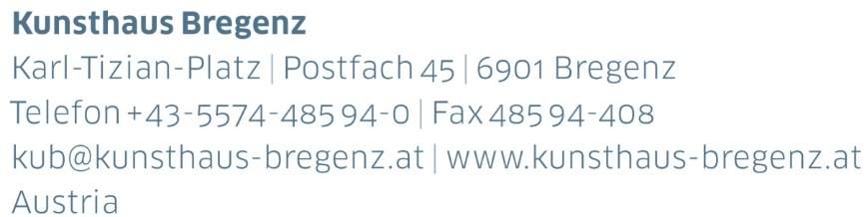

KUB 2024.02 | Press Release
Anne Imhof
Wish You Were Gay
08 | 06 — 22 | 09 | 2024

Press Conference
Thursday, June 6, 2024, at 11 am

Opening
Friday, June 7, 2024, at 7 pm

Press photos available for request at
www.kunsthaus-bregenz.at/en/press/anne-imhof

Kunsthaus Bregenz is delighted to announce Wish You Were Gay, an exhibition by Anne Imhof. Spanning all four floors of KUB, Wish You Were Gay is simultaneously a personal survey and an all new body of work that reflects on and further develops a number of core elements that have constituted Imhof’s repertoire of artistic expression. Wish You Were Gay includes bas-reliefs, large scale oil paintings, sculptures, stage elements and stadium lighting, as well as new video works made of archival footage from her origins as an artist coming of age in underground subcultures. Throughout the exhibition, Anne Imhof explores notions of finitude, reality and artifice, chance and fate, as well as absence and presence set against a backdrop of post-apocalyptic isolation. With the absence of a performance piece, the presence of an imagined narrative, its protagonists, and the physical movement central to Imhof’s practice are embedded within the work, turning the exhibition into a stage. Movement and performance are at the core of everything she does.

Biography
Anne Imhof

Anne Imhof (b. 1978, Giessen) is a German performance and media artist. She completed her studies at the Städelschule in Frankfurt am Main in 2012. For the 57th
Venice Biennale in 2017, she presented her work Faust in the German Pavilion for which she was awarded the Golden Lion for Best National Participation. This was
followed by solo exhibitions at Tate Modern in London in 2019, the Palais de Tokyo in Paris in 2021, and her first solo exhibition in the Netherlands at the Stedelijk Museum
Amsterdam in 2022, titled Youth.
Anne Imhof lives and works in Berlin and Los Angeles.
Partners and Sponsors
Kunsthaus Bregenz is grateful to its partners for their generous financial support and their ongoing commitment to culture.

